**Diagnostic Rev. 586220 Cartridge**

**Short description**

The diagnostic cartridge can be easily built from existing parts. All information was obtained from the website “World of Jani” (<http://blog.worldofjani.com/?p=164>). The binary file for programming the (27C512) EPROM was generated with the cartconv tool from the VICE C64 emulator from the 586220plus v0.4 CRT file, which was also downloaded from World of Jani.

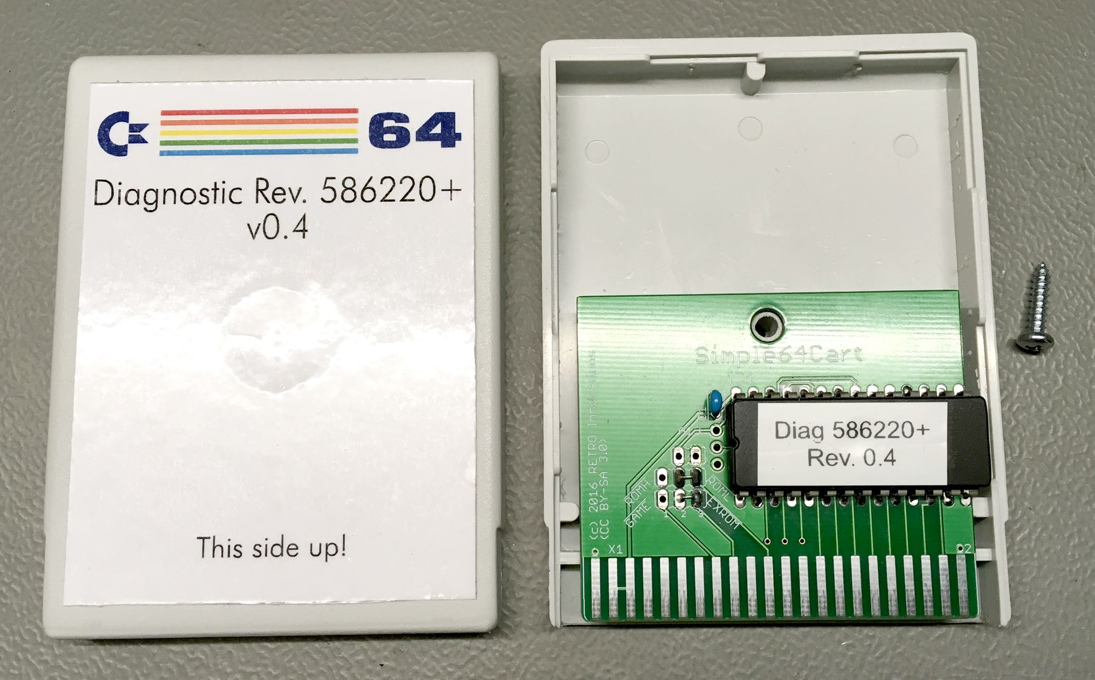

Figure 1: Diagnostic Cartridge with SimpleC64Cart

The cartridge can be made with a variety of existing cartridge boards. Here the SimpleC64Cart (<http://www.go4retro.com/downloads/Simple64Cart/>) was used.

The correct settings are /GAME=HIGH (open), /EXROM=LOW (closed jumper), and the /OE of the EPROM is connected to /ROML.

The SimpleC64Cart has a fixed setting for A13, A14 and A15 (all HIGH), so the binary file has to be loaded to Address 0xE000.

The cartridge case was purchased from retro-store.de ([https://restore-store.de/home/117-modulgehaeuse-c64c128-grau-ohne-labelfeld.html](https://restore-store.de/home/117-modulgehaeuse-c64c128-grau-ohne-labelfeld.html%20)). Those cases are low profile, which is the reason, why the EPROM is not socketed and the jumpers are bridged with wires.